Sterling Kendall

Bro. Cheney

CIT 230

May 19, 2018

**Tri-City Weather Site**

Author: Sterling Kendall

Site Purpose:

This site is to provide the local weather, events, and photo gallery pertaining to the Franklin, Greenville, and Springfield cities. It will be centered around the weather in the area covering projected, current, and past data. The Gallery will host viewer and company photos. The storm center will cover current and forecast weather. The home screen will display “snapshots” of all three cities and links to them.

Target Audience:

The target audience is the local demographic with high searchability for travelers and travel planners. We want to be the first source for all weather-related information in the Tri-City Area.

Site Map:

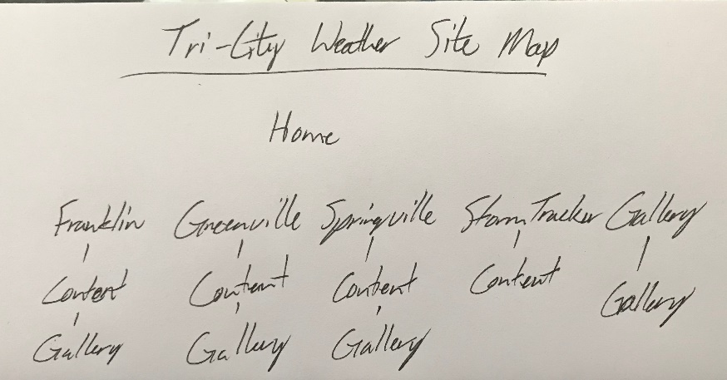

Color Scheme: I am using colors for each site, most are warm colors.

Typography: Font Family Playfair.

Wire-Frame Sketches:

